Sensor Fusion
Learning Objectives
- Introduction to Sensor Fusion in Robotics: Basic understanding of sensor fusion, its importance in robotics, and potential applications.
- Sensor Fusion for Autonomous Vehicles: An example of sensor fusion (like radar, LIDAR, ultrasonic, and cameras) are used together in autonomous cars.
- Multi-sensor Data Fusion Algorithms: Review of different fusion algorithms like Kalman Filters, Bayesian Networks, Markov Models, Particle Filters, etc.
Sensor Fusion
Sensor fusion is the process of applying collective information from various sensors to learn more about the environment or an object of interest. It is often used in robotics, self-driving cars, aircraft, and augmented reality, among other things. The main idea behind sensor fusion is that different sensors give information that complements each other. By combining their data, we can get around the limits of each sensor and get a more reliable and accurate picture of what's going on.
Importance of Sensor Fusion
There are a lot of benefits to using sensor fusion.
- Increased data quality
- Increased data reliability
- Estimation of unmeasured states
- Increased coverage areas
One of the perks of sensor fusion is that it makes the system more accurate, stable, and reliable. It also makes it easier to understand and make decisions. When multiple sensors are used together, duplicate information can be filtered out, noise can be cut down, and the system can better adapt to different situations and weather conditions.
Sensor fusion is a key part of advanced technologies like self-driving cars. Data from sensors like cameras, lidars, radars, and GPS are combined to create a full picture of the car's surroundings. This makes travel safe and reliable. In the same way, sensor fusion is important in robotics for jobs like localization, mapping, recognizing objects, and manipulation.
In autonomous vehicles, sensor fusion is crucial for accurately perceiving the environment and making informed decisions. A typical autonomous vehicle is equipped with various sensors such as cameras, lidars (laser-based sensors), radars, and GPS receivers. Each sensor provides unique information about the surroundings, and by fusing their data, the vehicle can obtain a comprehensive understanding of the road conditions.
Different Level of Sensor Fusion:
Sensor fusion can be achieved through various techniques, including:
Data-level fusion:
In this method, raw sensor data are added together directly to make a single picture. For example, if a self-driving car has a camera and a radar sensor, you can combine the raw image data from the camera with the distance and speed readings from the radar to get a better idea of what's going on around the car.
Feature-level fusion:
Instead of combining raw sensor measurements, this method takes important features from each sensor and combines them. In an augmented reality app, for example, visual data from a camera and position/orientation data from an inertial sensor can be combined to place virtual objects correctly in the real world.
Decision-level fusion:
In this method, each monitor makes a decision on its own, and all of these decisions are added together to make a final decision. For example, in a sensor network used to monitor the environment, different sensors may find pollution on their own, and a fusion algorithm can combine their results to estimate the overall amount of pollution.
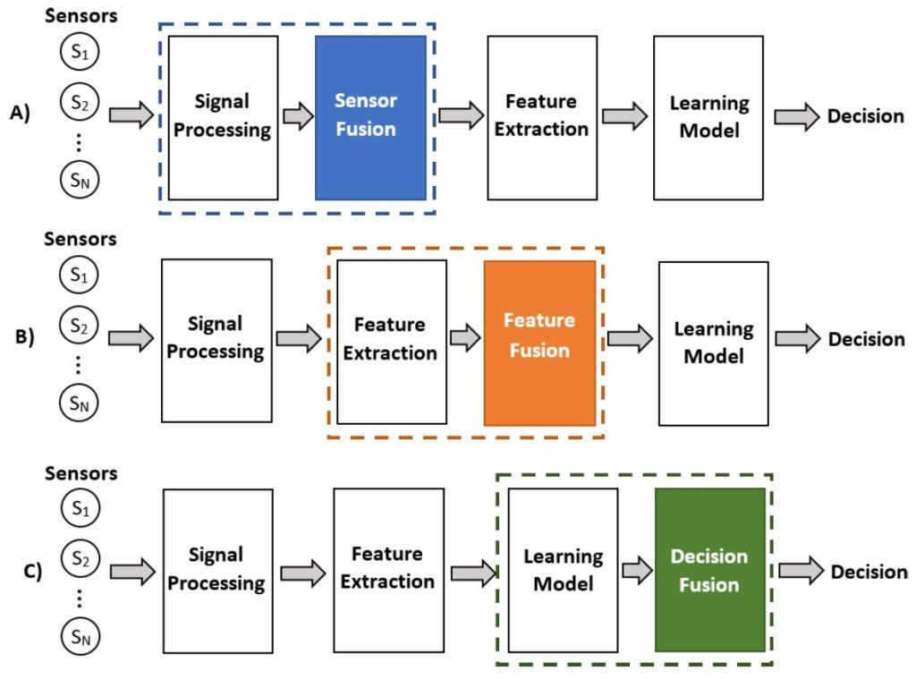
Figure: Different fusion levels. (a) Fusion of sensor data (in blue). (b) Sensor data represented by feature vectors and their corresponding fusion (in orange). (c) Decision fusion after classification models (in green). (Image: IEEE)
For more details: https://ieeexplore.ieee.org/document/8846583
Hybrid fusion:
Each data/sensor fusion model (statistical, probabilistic, and knowledge-based) can be used at different levels of processing abstraction. Hybrid models can also be used along with these three main levels. For example, data from two different sensors can be put together to make a single set of features, and the classification model that comes out of that can be used at the decision level. On the other hand, the results of feature extractions and decision level classifications for various modalities can be used to train and improve the decision level classification algorithms for other modalities. In this method, some or all of the above techniques are used, based on the needs of the application. The fusion process can be done with different fusion methods and models, such as Kalman filters, Bayesian inference, artificial neural networks, or fuzzy logic.

An Example of Sensor Fusion for Autonomous Vehicle
For instance, let's imagine an autonomous car approaching an intersection. The vehicle's camera captures a series of images that provide visual information about the road, including lane markings, traffic signs, and nearby vehicles. The lidar, on the other hand, emits laser beams and measures the time it takes for them to bounce back, creating a detailed 3D map of the environment. The radar sensor detects the velocity and distance of objects around the vehicle, including pedestrians and other vehicles. Finally, the GPS receiver provides location and positioning data.
Through sensor fusion, the autonomous vehicle can combine the data from all these sensors to make accurate decisions. Here's how it might work:
- Data-level fusion: The raw data from each sensor is collected and integrated. The camera images, lidar point clouds, radar measurements, and GPS coordinates are aligned in a common reference frame.
- Feature-level fusion: Relevant features are extracted from each sensor's data. The camera identifies lane markings, traffic signs, and objects in the scene. The lidar provides detailed 3D information about the shape and position of objects. The radar detects the velocity and distance of surrounding objects. These features are combined to form a more comprehensive representation of the environment.
- Decision-level fusion: The decisions made by each sensor are combined to make a final decision. For example, the camera might detect a stop sign, while the radar detects a pedestrian crossing. By fusing the decisions, the autonomous vehicle can accurately identify that there is a stop sign ahead and a pedestrian crossing the road simultaneously, enabling it to safely stop and avoid a collision.
By integrating data from multiple sensors, the autonomous vehicle can obtain a more robust and accurate perception of the environment. The redundancies among different sensors can help filter out noise, handle sensor failures or limitations, and provide a more reliable understanding of the driving scenario.
This is just one example of how sensor fusion can be applied in autonomous driving. Similar principles can be extended to other domains, such as robotics, where combining data from different sensors enhances perception and enables intelligent decision-making in complex and dynamic environments.
Overall, sensor fusion is a basic method that lets systems understand their surroundings by using the power of multiple sensors together. This lets systems make more accurate and smarter decisions.
Multi-sensor Data Fusion Algorithms
Bayesian Networks:
A Bayesian network is a graphical model (Graphical Model) that shows how a set of factors are likely to be related. It gives a short way to think about how to deal with uncertainty. Each "node" in the graph is a variable, and the "edges" between the nodes show how the variables rely on each other under certain conditions. It's used when we know how different senses depend on each other or don't depend on each other under certain conditions. They can be very creative and deal well with uncertainty, but they can also be hard to use and take a lot of processing power.

In the Bayesian network, each sensor can be thought of as a variable when it comes to sensor fusion. The readings from each monitor depend on how the world is, but they can also be affected by noise and mistakes. So, the reading from each monitor can be thought of as a probabilistic function (Probability function) of how the real world is. Bayesian networks are a way to mix information from different sources in a structured way. If two sensors measure the same underlying feature of the world (like temperature, distance to an obstacle, etc.), the Bayesian network can combine the information from these sensors to get a more accurate estimate of the feature. This is done by figuring out the conditional probabilities(Conditional probability) of each feature given the readings from each sensor and then mixing these probabilities in a way that considers how reliable each sensor is.
One of the best things about Bayesian networks is that they can deal with uncertainty. Each reading from a sensor can be affected by noise and mistakes, which can be modeled as doubts in a Bayesian network. By making these doubts clear, the network can make predictions that take each sensor's accuracy into account. Bayesian networks are based on the idea of Bayesian updating. This means that as new sensor readings come in, they can change their estimates of the state of the world. This lets the network adjust to changes in the surroundings and get better at making predictions over time.
For more information:
- https://ieeexplore.ieee.org/document/4086096
- https://www.cs.ubc.ca/~murphyk/Bayes/bnintro.html
Kalman Filters:
The Kalman Filter is a recursive prediction-correction algorithm that assumes the system is linear and the noise is Gaussian. It is often used in applications such as navigation, control systems, and computer vision. The Extended Kalman Filter (EKF) and Unscented Kalman Filter (UKF) are extensions of the Kalman filter that are used when the system is non-linear. While the EKF linearizes the non-linear system around a point, the UKF uses a deterministic sampling technique to pick a minimal set of sample points around the mean.
The Kalman Filter is a powerful tool in sensor fusion, particularly in situations where you are trying to estimate the state of a system over time given noisy input data. This state could be anything from the position and velocity of a vehicle to the orientation of a robot, and the data can come from multiple sensors.
The Kalman filter works in two steps: predict and update. The prediction step uses the current state and model of the system to predict the state at the next time step. The update step uses the new observation to correct the predicted state, combining the prediction and the new observation to get an updated state estimate.
Consider a simple example: you have a robot moving in a straight line and you're trying to estimate its position. You have two sensors - a wheel encoder that measures distance traveled, and a GPS that gives you the absolute position.
Here's how the Kalman Filter works in this scenario:
1. Prediction step:
The filter predicts the robot's next position based on the previous position and the wheel encoder readings. Let's say the encoder data suggests the robot has moved forward by 1 meter.
2. Update step:
The GPS sensor then gives a new reading. Let's say the GPS data suggests that the robot is 1.2 meters from the start. The Kalman filter now has two estimates for the robot's position: the prediction from the encoder (1 meter) and the new observation from the GPS (1.2 meters). The Kalman filter then weights these estimates based on their uncertainty (the GPS is usually more uncertain due to things like signal noise). If, for example, the GPS has twice as much uncertainty as the encoder, the Kalman filter might estimate the robot's position to be 1.07 meters from the start. This is a weighted average of the two estimates (1 meter and 1.2 meters), giving more weight to the encoder reading because it's less uncertain.
This process is then repeated at every time step, allowing the Kalman filter to continuously refine its estimate of the robot's position as new data comes in. It's a powerful tool because it doesn't just take the sensor readings at face value. Instead, it combines them intelligently based on their uncertainties to provide a more accurate and reliable estimate.
It's worth noting that the Kalman filter assumes the system is linear and the noise is Gaussian. In systems that are not linear, extensions of the Kalman filter, such as the Extended Kalman Filter or Unscented Kalman Filter, are used.
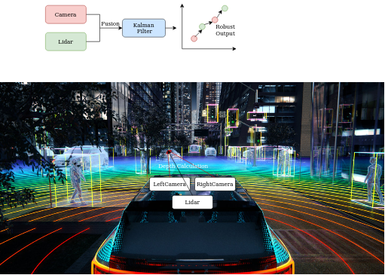
Figure: Autonomous Vehicle is using various sensors (Source: Image)
For more details:
- https://medium.com/@satya15july_11937/sensor-fusion-with-kalman-filter-c648d6ec2ec2
- https://ieeexplore.ieee.org/abstract/document/859866

Hidden Markov Models (HMMs):
Hidden Markov Models are statistical models that assume a Markov process with hidden states. It is a statistical model that is commonly used for sequential data analysis, including sensor fusion. Sensor fusion refers to the process of combining data from multiple sensors to obtain a more accurate and reliable estimate of the underlying state of a system. In robotics, they're often used for tasks like robotic arm movement, where the actual state (arm position) isn't directly observable but can be inferred from related observations. HMMs can handle the uncertainty in both the system and observations well, but they also assume that the system is a first-order Markov process, which may not always be the case.
More Information: https://ieeexplore.ieee.org/document/4632276

Particle Filters:
A probabilistic technique called Sequential Monte Carlo methods is used in robots and autonomous systems for sensor fusion. It is also known by its other name, Sequential Monte Carlo methods. These filters use a set of random samples (called "particles") to show the system's posterior density function. They work well with non-linear and non-Gaussian systems, but they can be hard to calculate, especially as the problem gets more complicated. In robotics, particle filters are often used for SLAM and robot localization. The particle filter calculates the state by putting together the weighted particles, usually using the weighted mean or another statistical report. The result is a reliable and flexible estimate of the state of the system that considers input from multiple sources and uncertainty.
More Information: https://iopscience.iop.org/article/10.1088/0957-0233/16/3/008

